**A Mini Project Report**

**On**

**TRAFFIC ANOMALY DETECTION**



Submitted by

**Miss. N.MOHANA LAKSHMI**

**Regd. Number: 21B91A05L0**

**DEPARTMENT OF COMPUTER SCIENCE ENGINEERING**

**S. R. K. R ENGINEERING COLLEGE (A)**

**(Affiliated to JNTU, KAKINADA)**

**BHIMAVARAM-534204**

**(2023-2024)**

**DEPARTMENT OF COMPUTER SCIENCE AND ENGINEERING**

**S. R. K. R ENGINEERING COLLEGE BHIMAVARAM**



**CERTIFICATE**

This is to certify that this is a bonafide work on “**TRAFFIC ANOMALY DETECTION**” as a Machine Learning laboratory report submitted by Miss.Nallala Mohana Lakshmi **(21B91A05L0)** in partial fulfillment of the requirements for the award of the Degree of Bachelor of Technology in Computer Science and Engineering, during the academic year 2023-2024. The candidates worked right under our Supervision and guidance.

**Lecturers In-Charge**

S SURYANARAYANA RAJU **Head of The Department**

Assistant Professor Dr. V CHANDRA SEKHAR

Department of CSE Department of CSE

S.R.K.R Engineering College S.R.KR Engineering College

Bhimavaram Bhimavaram

**ACKNOWLEDGEMENT**

We take immense pleasure in thanking **Prof. K V Murali Krishnam Raju**, beloved principal of S.R.K.R Engineering College, Bhimavaram, and **Dr. V. Chandra Shekar**, esteemed **Head of the** **Department** (C.S.E), for having permitted us to carry out this Machine Learning project work.

We wish to express our deep sense of gratitude, especially to our project Guide**, S Suryanarayana Raju, Assistant Professor** for the guidance and useful suggestions, which helped us in completing the project work, on time. Finally, yet importantly, We would like to express my heartful thanks to our beloved parents, faculty, our friends/classmates for their help, and our wishes for the successful completion of this project.

Nallala Mohana Lakshmi

(21B91A05L0)

**Table of Contents**

Abstract 5

**1.** **Introduction** 6

**1.1.** **Background** 6

**1.2.** **Problem Statement** 6

**1.3.** **Objective** 6

**2.** **Literature Review** 6

**2.1.** **Review of relevant literature** 6

**2.2.** **Previous Approaches** 7

**3.** **Methodology** 7

**3.1.** **Data Collection** 7

**3.2.** **Data Preprocessing** 8

**3.3.** **Model Architecture** 8

**3.4.** **Training Process** 9

3.4.1. Step 1: Setup and Initialization 9

3.4.2. Step 2: Loading YOLOv8 pre-trained Model 9

3.4.3. Step 3: Dataset Exploration 9

3.4.4. Step 4: Fine-Tuning YOLOv8 10

3.4.5. Step 5: Model Performance Evaluation 10

3.4.6. Step 6: Model Inference and Generalization Assessment 11

3.4.7. Step 7: Real-Time Intensity Estimation 11

3.4.8. Step 8: Model Export for Cross-Platform Deployment 11

**3.5.** **Code** 11

**4.** **Results and Analysis** 18

**4.1.** **Presentation of results** 18

4.1.1. Model Robustness 18

4.1.2. Output Discussion 18

**4.2.** **Benefits** 24

**5.** **Conclusion** 24

**5.1.** **Summary of Project** 24

**6.** **References** 24

# Abstract

Our project focuses on the development of an advanced system for vehicle detection and traffic density analysis with deep learning techniques. We utilize the YOLO (You Only Look Once) object detection model, to identify vehicles within images and video streams. To train our model, we curate a diverse dataset comprising vehicle images from various real-world scenarios. Rigorous preprocessing, including data augmentation and normalization, ensures the model's adaptability to diverse environmental conditions. Upon training, our YOLO model demonstrates exceptional performance, achieving high precision and recall rates in vehicle detection tasks. We augment the system to include lane-specific vehicle detection and quantification of traffic intensity levels. Furthermore, our system incorporates predictive analytics capabilities to anticipate anomalies in traffic based on traffic intensity metrics. By analyzing deviations from typical traffic patterns, the system can forecast the likelihood of anomaly occurrences. This feature enhances proactive decision-making in traffic management by enabling early intervention and mitigation strategies. Through comprehensive visualizations and performance metrics, we demonstrate the system's ability to provide valuable insights into traffic dynamics and facilitate informed decision-making in traffic management and urban planning endeavors.

**Keywords:** Vehicle Detection, Traffic Density Analysis, Deep Learning, YOLO (You Only Look Once), Object Detection, Lane-specific Analysis, Anomaly Detection, Predictive Analytics, Image Processing, Data Preprocessing, Model Training, Performance Evaluation, Binary Classification, Data Augmentation, Normalization Techniques, Performance metrics.

# **Introduction**

# **Background**

The advent of deep learning methodologies has revolutionized various fields, including computer vision and transportation. Traditional methods for vehicle detection and traffic analysis often relied on manual intervention or simplistic algorithms, leading to limitations in accuracy and efficiency. With the emergence of deep learning models like YOLO (You Only Look Once), it has become possible to achieve real-time and highly accurate vehicle detection and traffic density analysis in complex scenarios.

# **Problem Statement**

Despite advancements in deep learning, there remains a need for robust systems capable of effectively managing traffic flow and congestion in urban areas. Traffic management authorities require tools that can accurately detect vehicles, analyze traffic density, and predict anomalies in real-time to facilitate proactive decision-making and enhance overall traffic efficiency. Addressing these challenges requires the development of sophisticated deep learning-based systems tailored to the specific needs of traffic management and urban planning.

# **Objective**

1. **YOLOv8 Model Selection and Initial Assessment:** Starting with YOLOv8's pre-trained model selection, assessing its initial performance on COCO dataset for vehicle detection.
2. **Specialized Vehicle Dataset Preparation:** Curating and annotating a vehicle-specific dataset to refine the model's detection capabilities for diverse vehicle types.
3. **Model Fine-Tuning for Enhanced Vehicle Detection:** Employing transfer learning to fine-tune the YOLOv8 model, focusing on vehicle detection from aerial perspectives for improved precision and recall.
4. **Comprehensive Model Performance Evaluation:** Analyzing learning curves, evaluating confusion matrix, and assessing performance metrics to validate the model's accuracy and generalization capabilities.
5. **Inference and Generalization on Test Data:** Testing the model's generalization on validation images, an unseen test image, and a test video to demonstrate its practical application and effectiveness.
6. **Real-Time Traffic Density Estimation:** Implementing an algorithm to estimate traffic density by counting vehicles and analyzing traffic intensity in real-time on test video data.
7. **Cross-Platform Model Deployment Preparation:** Exporting the fine-tuned model in ONNX format for versatile use across different platforms and environments.

# **Literature Review**

# **Review of relevant literature**

In recent years, the fields of computer vision and traffic analysis have seen an abundance of models and methodologies developed for various tasks, including object detection, traffic density analysis, and anomaly detection. Here, we review the existing models and approaches pertinent to our project:

* **Object detection models:**

1. Faster R-CNN: Proposed by Ren et al., Faster R-CNN introduced Region Proposal Networks (RPNs) to efficiently generate region proposals, followed by a Fast R-CNN detector for object detection.
2. SSD (Single Shot MultiBox Detector): Introduced by Liu et al., SSD offers a single-shot detection pipeline that predicts object locations and class probabilities directly from feature maps of multiple scales.
3. YOLO (You Only Look Once): YOLO models, developed by Redmon et al., adopt a unified architecture that predicts bounding boxes and class probabilities directly from full images in a single pass. YOLOv4, YOLOv5, and other variants have achieved impressive speed and accuracy trade-offs for object detection tasks.

* **Traffic analysis:**

1. C3D (Convolutional 3D Network): Originally proposed for action recognition in videos, C3D has been adapted for traffic analysis tasks such as vehicle counting and tracking.

FlowNet: FlowNet architectures, developed for optical flow estimation, have been utilized for traffic flow analysis tasks, including vehicle trajectory prediction and congestion detection.

# **Previous Approaches**

* **Traditional approaches:**

1. Feature-based Methods: Traditional approaches such as Histogram of Oriented Gradients (HOG) and Scale-Invariant Feature Transform (SIFT) have been widely used for object detection.
2. Template Matching: Template matching techniques have been employed for vehicle detection and tracking by comparing image patches to predefined templates of vehicles.

* **Modern Learning**:

1. Ensemble Learning: Ensemble methods such as Random Forests and Gradient Boosting Machines (GBMs) have been utilized for combining multiple weak classifiers to improve object detection and classification performance.

# **Methodology**

# **Data Collection**

1. **Source of Image Data:** The dataset was obtained from the "Vehicle Detection Image Dataset" repository, available in Kaggle. This dataset comprises a collection of images captured from traffic cameras and surveillance systems, capturing diverse traffic scenarios.
2. **Dataset Composition:** The dataset consists of a total of 626 images, encompassing a wide range of traffic conditions, including different times of day, weather conditions, and traffic densities. The images depict various road types, environments, and vehicle types, ensuring model robustness and generalization to real-world scenarios.
3. **Partitioning of Dataset**: The dataset was partitioned into training and validation sets using an 85-15 split. This partitioning strategy ensured that the model could learn from a separate set of images for evaluating model performance during training.

# **Data Preprocessing**

1. **Image Resizing:** All images in the dataset were resized to a uniform resolution of 640X640 pixels, suitable for the chosen model architecture (YOLOv4).
2. **Normalization:** Pixel values in the resized images were normalized to the range [0, 1] to facilitate convergence during training.
3. **Data Augmentation:** Augmentation techniques such as random rotation, flipping, and brightness adjustments were applied to the training images to increase dataset diversity and improve model generalization.

# **Model Architecture**

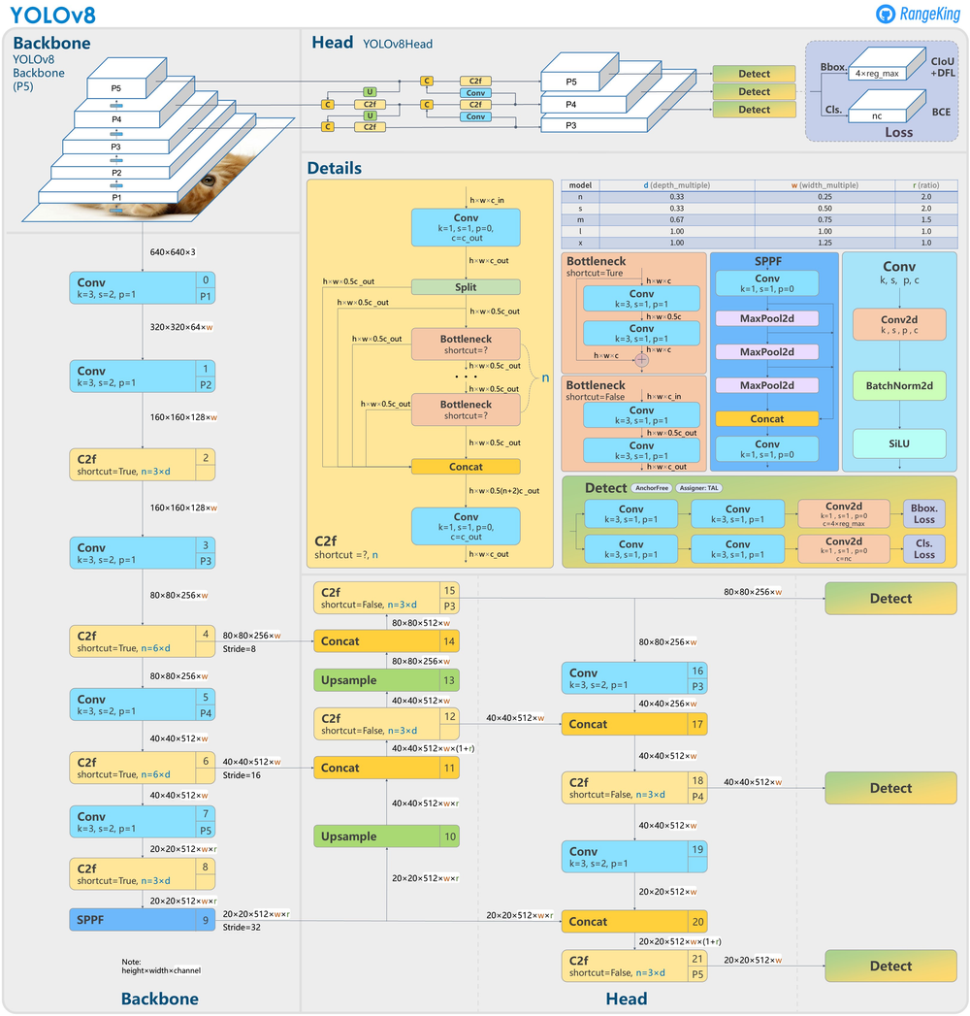

# **Training Process**

It includes 8 steps:

## **Step 1: Setup and Initialization**

* YOLOv8 is the first version of the YOLO series to offer an official package that can be easily installed using pip. This is an advancement from previous versions that required cloning repositories and running scripts. Importing all the required libraries.

## **Step 2: Loading YOLOv8 pre-trained Model**

* 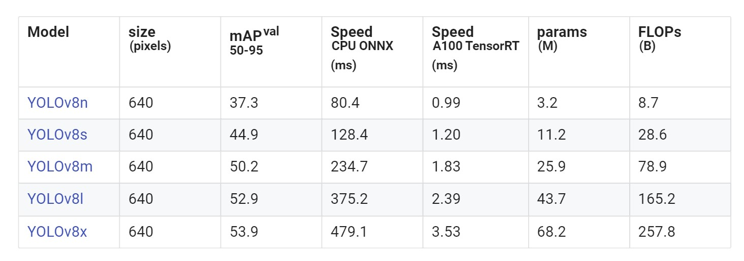The Common Objects in Context (COCO) dataset is extensive, designed for object detection, segmentation, and captioning, and encompasses 80 diverse object categories.
* The pre-trained model we've loaded is trained on the COCO dataset, which includes the 'car' and 'truck' classes among its 80 different categories.

## **Step 3: Dataset Exploration**

* **Dataset Preparation for Model Fine-tuning**
* To fine-tune our pre-trained model on a specialized dataset that focuses solely on vehicles, so that it can learn to detect various types of vehicles more accurately. The dataset zeroes in on the 'Vehicle' class, covering a wide variety of vehicles such as cars, trucks, and buses. It is composed of 626 images, annotated meticulously in the YOLOv8 format for effective vehicle detection.
* The dataset undergoes a standardization process where each image is resized to a uniform resolution of 640x640 pixels. To bolster the model's ability to generalize, augmentations were applied to the training data, which consists of 536 images. The validation set contains 90 images and remains unaugmented to preserve the integrity of performance evaluation.
* **YOLOv8 Dataset Format**
* Our dataset encompasses all necessary components for an efficient object detection model training:
* *Train Directory*:

The 'train' directory houses our training dataset. It includes 536 images within the 'images' subfolder and corresponding YOLOv8 format labels in the 'labels' subfolder.

* *Validation Directory:*

The 'valid' directory contains the validation dataset. This consists of 90 images in the 'images' subfolder and their respective YOLOv8 format labels in the 'labels' subfolder.

* *data.yaml:*

This file is the Ultralytics YOLO dataset configuration file. It specifies paths to the training and validation datasets, defines the number of classes (1), and the class name ('Vehicle'). This format is crucial for setting up and training the model accurately with our dataset.

## **Step 4: Fine-Tuning YOLOv8**

* A model is built and the model is executed.
* **Run summary:**

|  |  |
| --- | --- |
| lr/pg0 | 0.00024 |
| lr/pg1 | 0.00024 |
| lr/pg2 | 0.00024 |
| metrics/mAP50(B) | 0.97464 |
| metrics/mAP50-95(B) | 0.74355 |
| metrics/precision(B) | 0.91569 |
| metrics/recall(B) | 0.9381 |
| model/GFLOPs | 8.194 |
| model/parameters | 3011043 |
| model/speed_PyTorch(ms) | 4.045 |
| train/box_loss | 0.78149 |
| train/cls_loss | 0.39107 |
| train/dfl_loss | 0.89041 |
| val/box_loss | 0.95287 |
| val/cls_loss | 0.4646 |
| val/dfl_loss | 0.93712 |

## **Step 5: Model Performance Evaluation**

* Post-training, our model generates several files and folders that encapsulate various aspects of the training run.
* **Training Output Files**:
* *Weights Folder*: Contains the best and most recent weights of our model.
* *Args*: A file that stores the arguments or parameters that were used during the training process.
* *Confusion Matrix*: Visual representations of the model performance.
* *Events File*: Contains logs of events that occurred during training.
* *F1 Curve*: Illustrates the F1 score of the model over time, balancing precision and recall.
* *Labels*: Shows the distribution of different classes within the dataset.
* *P Curve, PR Curve, R Curve*: These are Precision, Precision-Recall, and Recall curves, respectively, providing insights into the trade-offs between different metrics at various thresholds.
* *results*: This csv file captures a comprehensive set of performance metrics recorded at each epoch during the model's training process.
* *Train Batch Images*: Sample images from the training set with model predictions overlaid.
* *Validation Batch Images*: Similar to train batch images, these are from the validation set and include both labels and predictions.
* **Evaluation and analysis**
* Here three evaluation metrics were found out:
* Step 5.1 -- Learning Curves Analysis
* Step 5.2 -- Confusion Matrix Evaluation
* Step 5.3 -- Performance Metrics Assessment

## **Step 6: Model Inference and Generalization Assessment**

* **Assessing our models ability to generalize**
* Here Inference is conducted in three steps:
* Step 6.1 -- Inference on Validation Set Images
* Step 6.2 -- Inference on an Unseen Test Image
* Step 6.3 -- Inference on an Unseen Test Video

## **Step 7: Real-Time Intensity Estimation**

* Our objective is to quantify the traffic by counting vehicles within specified areas on the road lanes, frame by frame. The analysis will not only reveal the vehicle count but also gauge the intensity of traffic, labelling it as 'Heavy' or 'Smooth' based on a predetermined threshold. The count and traffic flow insights are pivotal for urban planning and traffic management.

## **Step 8: Model Export for Cross-Platform Deployment**

* Exporting our best model for future use and deployment. To enhance the model's versatility and ensure it can be utilized across various platforms, we exported it to the ONNX (Open Neural Network Exchange) format. ONNX is specially designed for model portability, enabling seamless operation across different machine learning frameworks including PyTorch, TensorFlow, and Microsoft's Cognitive Toolkit (CNTK), as well as compatibility with specialized hardware accelerators.

# **Results and Analysis**

* The result images are labeled iamges

# **Presentation of results**

## **Model Robustness**

* *Precision, Recall, and mAP*: The YOLOv8 model achieved high precision and recall rates, resulting in an impressive mean average precision (mAP) score.
* *Detection Accuracy*: The model demonstrated robust performance in accurately detecting vehicles within images and video streams, as evidenced by the overlaid bounding boxes on sample images.
* *Traffic Analysis Results*: Comprehensive insights into traffic density, vehicle counts, and lane-specific analysis were obtained, showcasing the model's ability to capture intricate traffic dynamics.

## **Output Discussion**

* *Model Robustness:* The YOLOv8 model exhibited resilience in detecting vehicles across diverse environmental conditions and traffic scenarios, ensuring reliable performance in real-world applications.
* *Real-world Applicability:* The model's effectiveness in traffic surveillance and management systems was validated, highlighting its potential to enhance traffic efficiency and safety in urban areas.
* 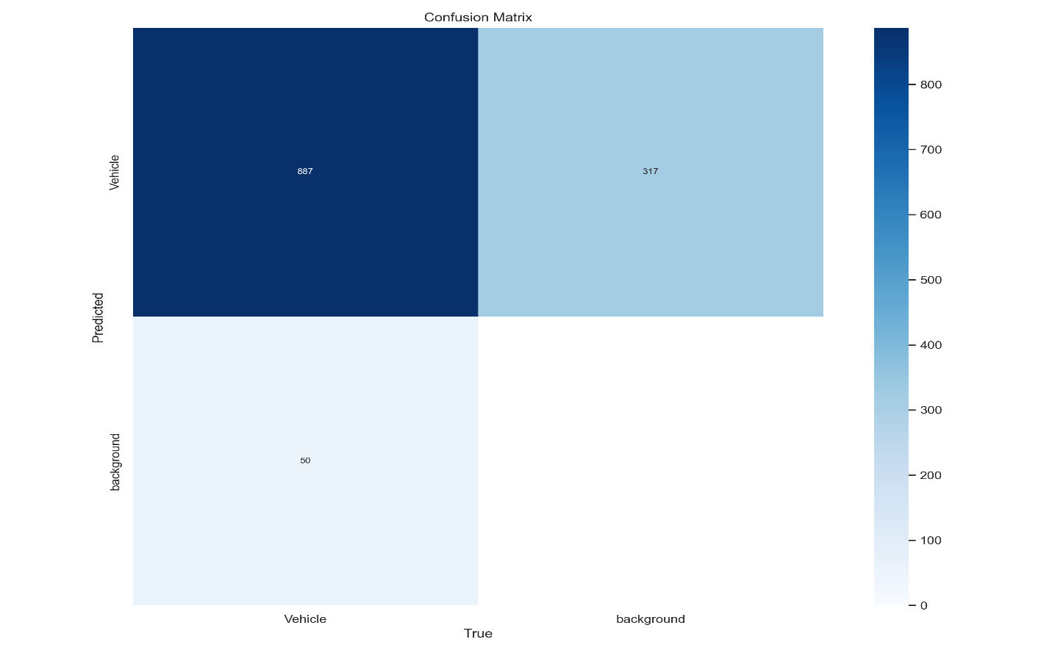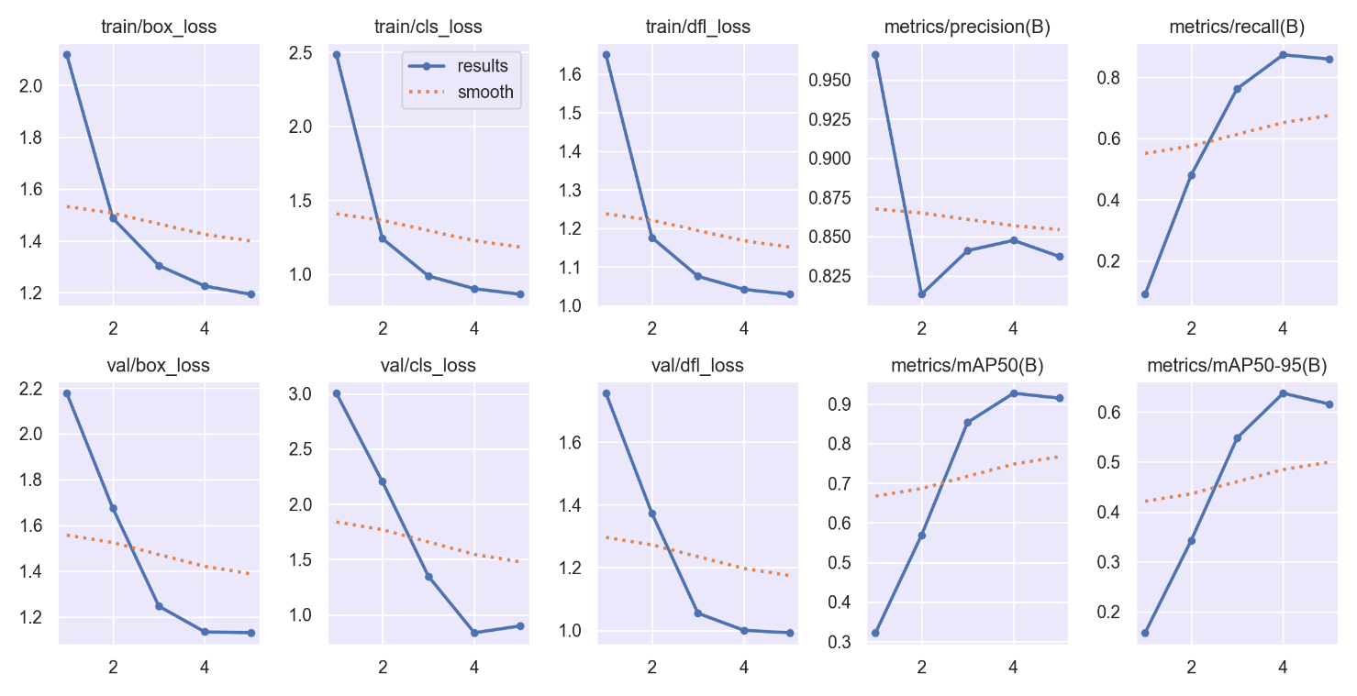*Anomaly Detection Capability*: By analyzing traffic intensity metrics, the model demonstrated promising capabilities in predicting anomalies and facilitating proactive decision-making in traffic management.

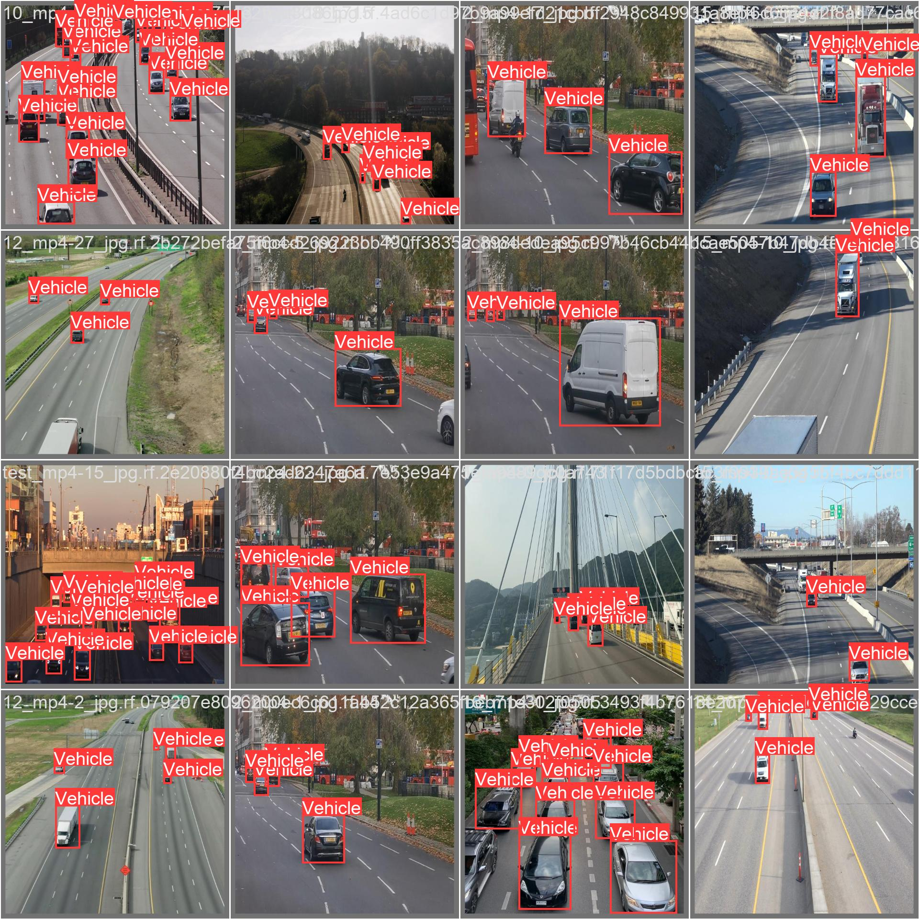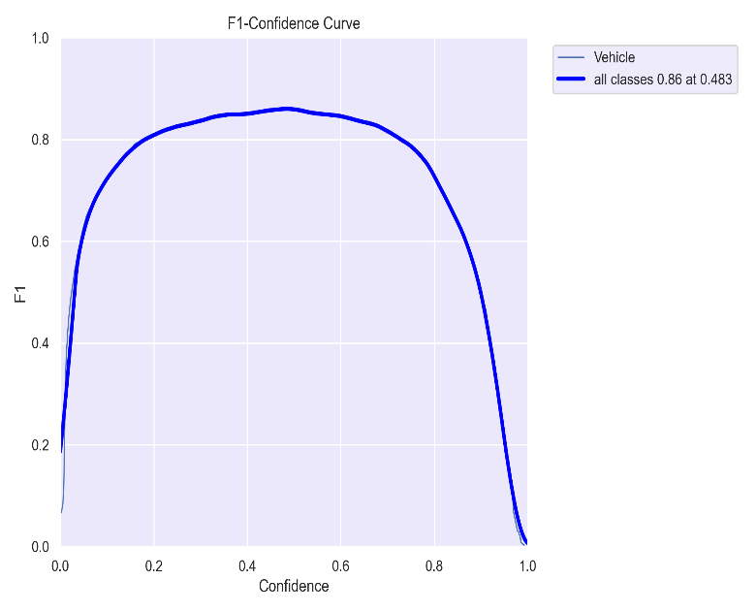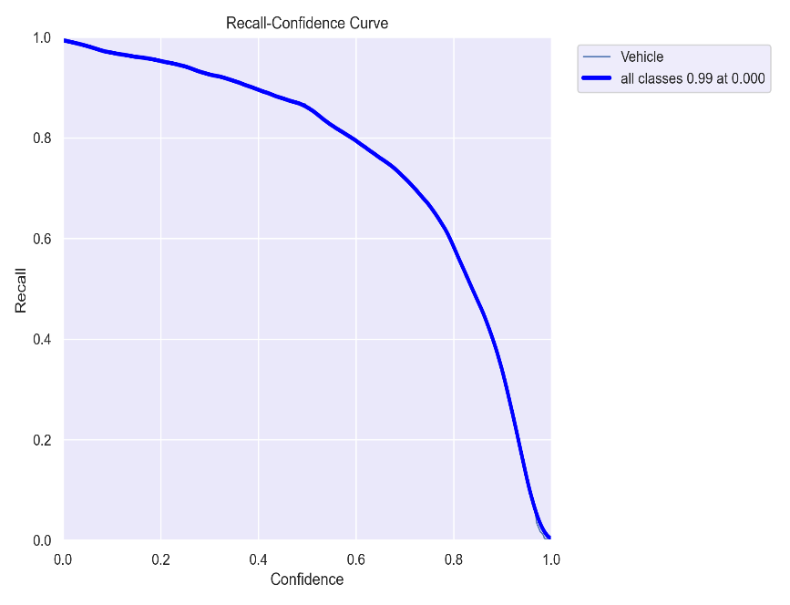

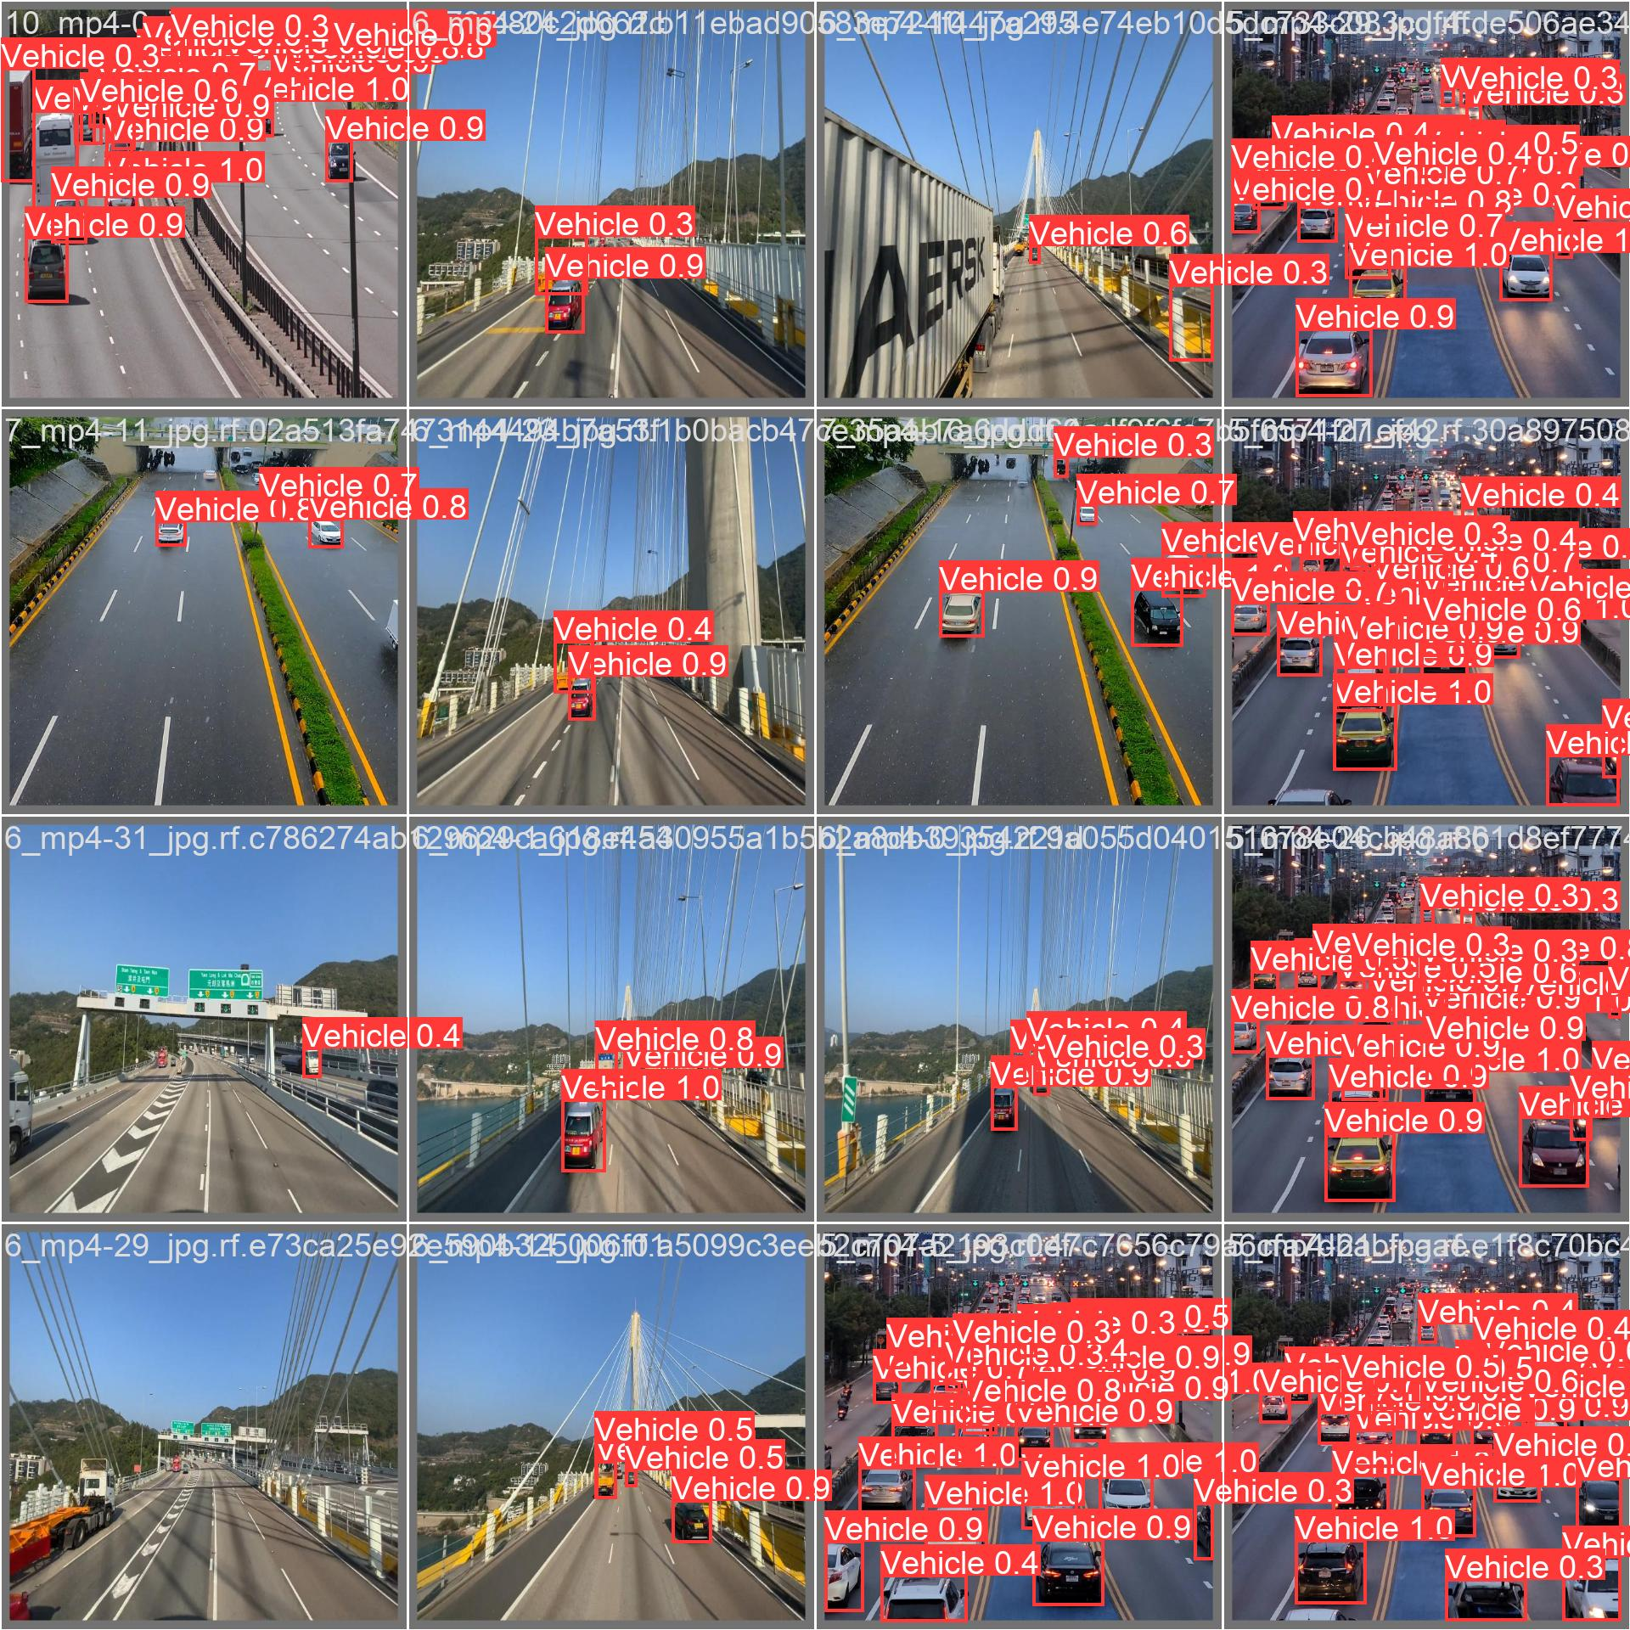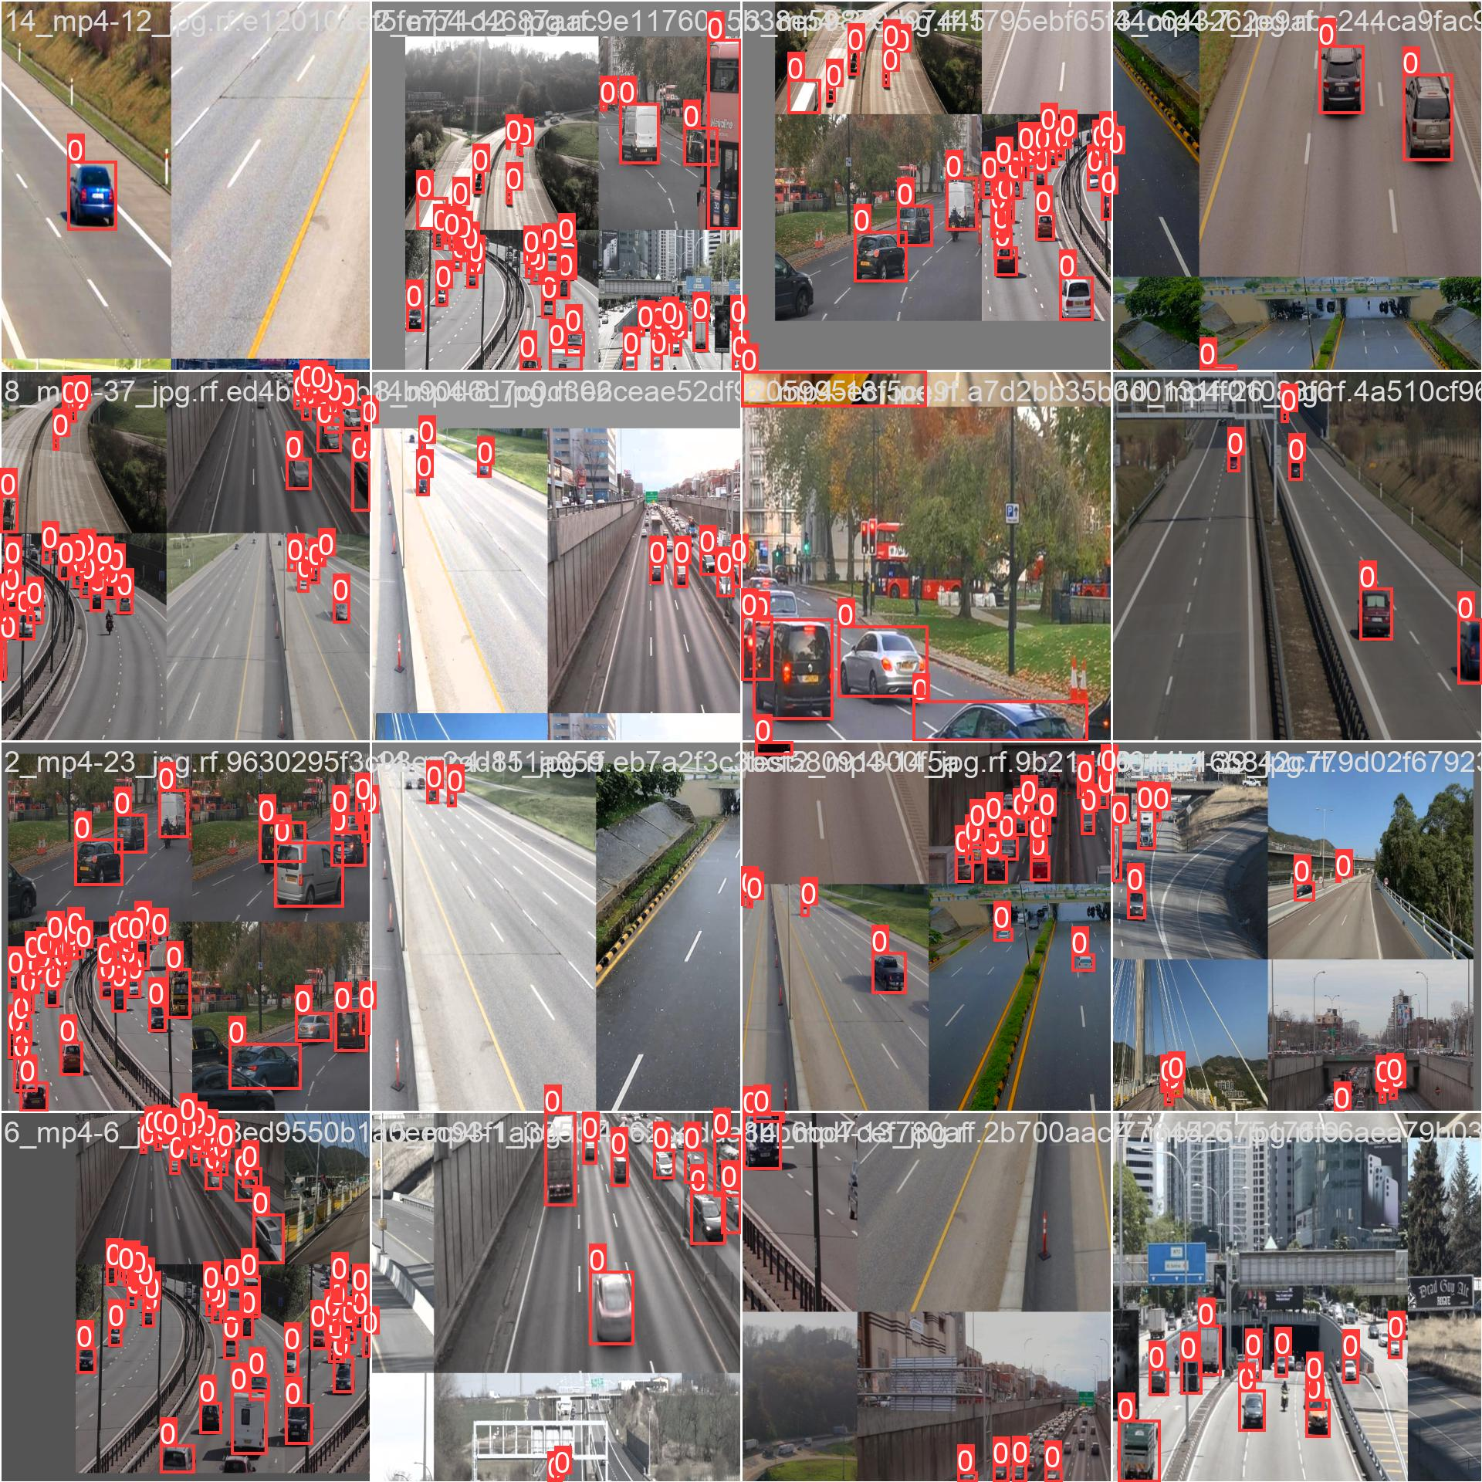

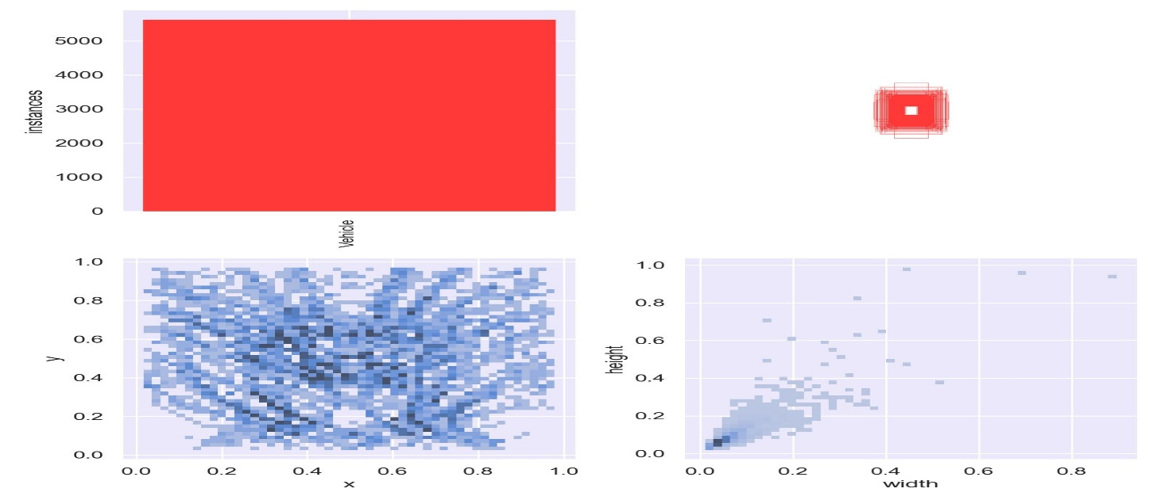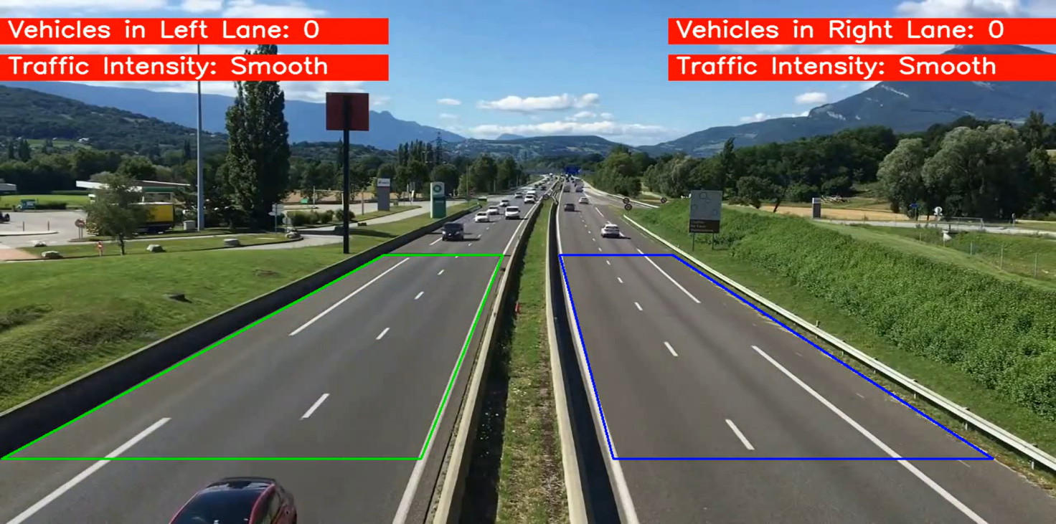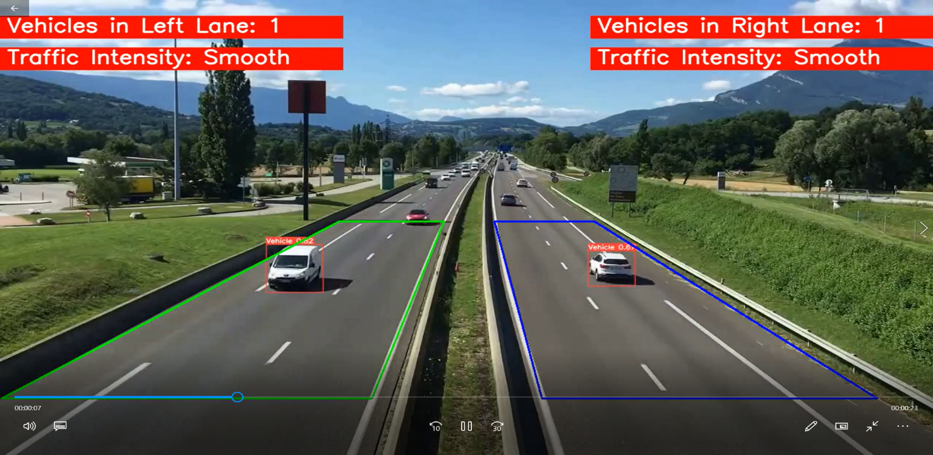

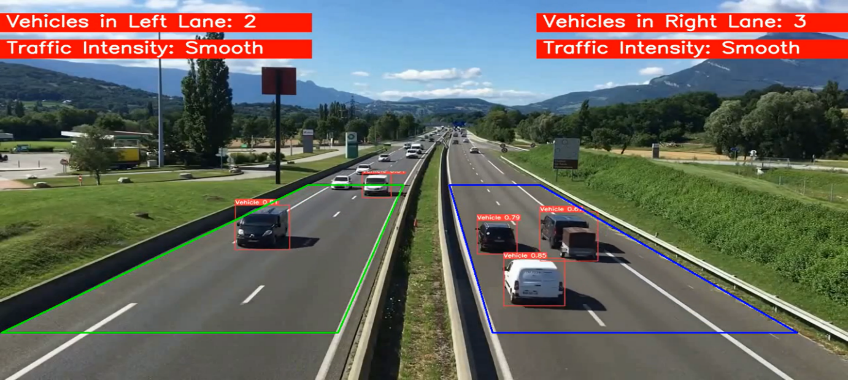

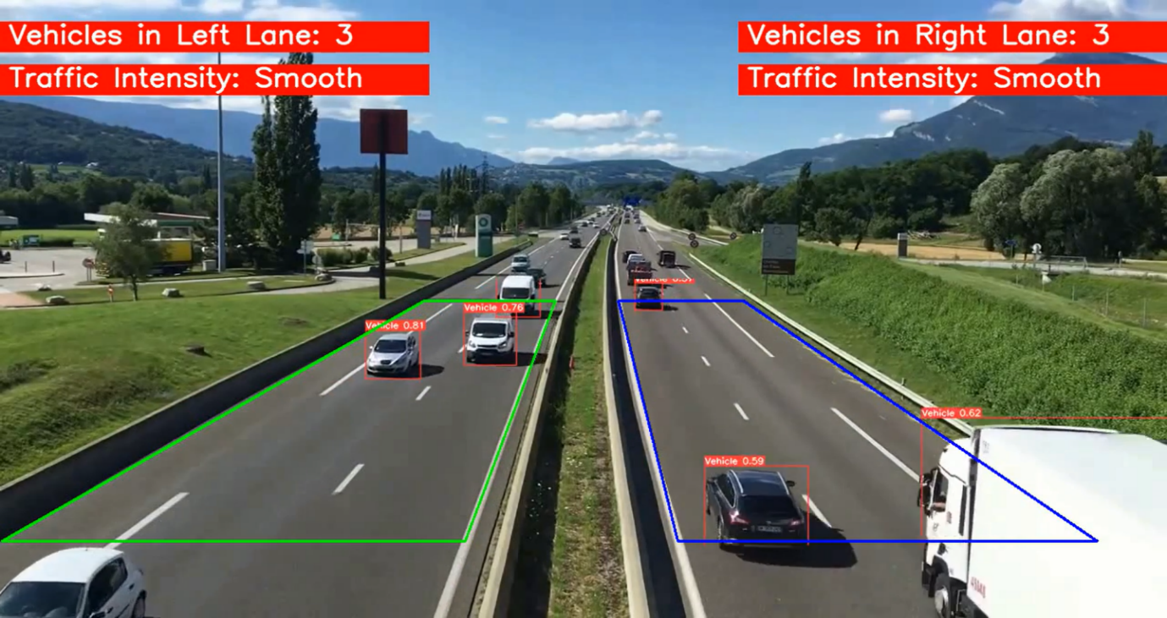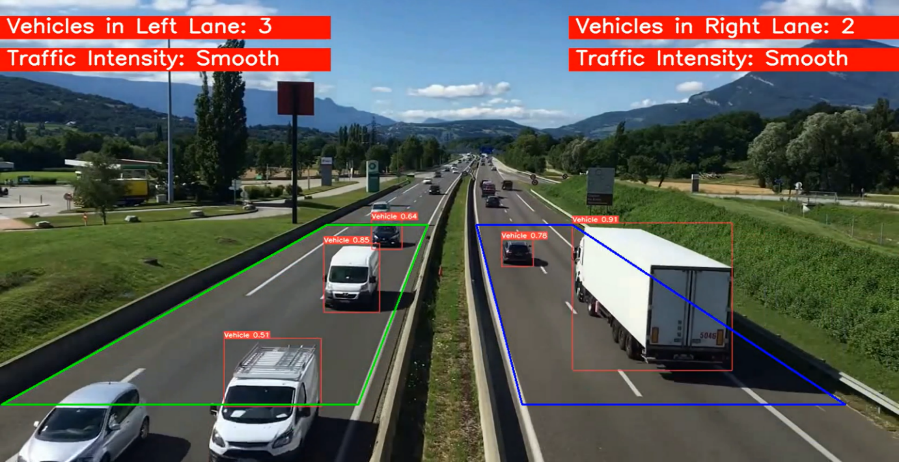

# **Benefits**

* *Real-world Applicability*: The deployment of the model in traffic surveillance systems benefits in traffic flow optimization, congestion management, and incident detection. The model's real-time analysis capabilities enable prompt responses to changing traffic conditions.

# **Conclusion**

# **Summary of Project**

* Our project aimed to develop an advanced system for vehicle detection and traffic density analysis using deep learning techniques, with a focus on the YOLOv8 model.
* We successfully curated a diverse dataset of 626 vehicle images sourced from the "Vehicle Detection Image Dataset" repository on Kaggle, encompassing various traffic scenarios and environments.
* Implemented the YOLOv8 model for vehicle detection and traffic density analysis, achieving high precision and recall rates.
* Utilized transfer learning to fine-tune the model on a specialized dataset, enhancing its ability to detect different types of vehicles accurately.
* Conducted comprehensive model performance evaluation, including learning curve analysis, confusion matrix evaluation, and assessment of performance metrics.
* Successfully estimated real-time traffic intensity levels using the developed system, enabling proactive decision-making in traffic management.
* The trained YOLOv8 model demonstrated excellent performance, with a mean Average Precision (mAP) of 97.46% and high precision and recall values.
* Confusion matrix evaluation provided insights into the model's ability to correctly classify vehicles and distinguish between different traffic scenarios.

# **References**

1. **Kaggle –** [Real-Time Traffic Density Estimation with YOLOv8](https://www.kaggle.com/code/farzadnekouei/real-time-traffic-density-estimation-with-yolov8)
2. **Medium --** [YOLOv8 model architecture and details](https://medium.com/@juanpedro.bc22/detailed-explanation-of-yolov8-architecture-part-1-6da9296b954e)
3. **Research Gate –** [Traffic intensity estimation](https://www.researchgate.net/publication/345019949_Machine_Learning_and_Deep_Learning_Models_for_Traffic_Flow_Prediction_A_Survey)
4. **Free code camp –** [Object detection using YOLOv8](https://www.freecodecamp.org/news/how-to-detect-objects-in-images-using-yolov8/)